The Earth moves around the Sun with its rotation axis tilted at 23° as shown in the diagram (not to scale).
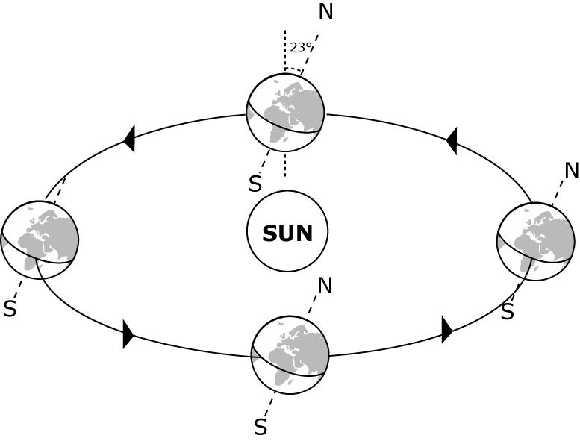

Suppose that the Earth’s axis was made to tilt at 35°, without changing anything else. What effect would this have?

(a) The length of the day from midnight to midnight would be

A Longer than 24 hours
B Shorter than 24 hours
C 24 hours

